**REQUEST FOR PROPOSALS**

**65-67 ½ Parsonage Street**

**VACANT LOT REQUEST FOR PROPOSALS**

TWO (2) HARD COPY, SEALED RESPONSES ARE DUE NO LATER THAN 12:00PM (NOON), FRIDAY, JULY 15 2024 AT THE OFFICE OF THE NORTH EAST PA LAND BANK, ATTENTION PARSONAGE STREET PROPOSAL, CITY HALL, 35 BROAD STREET, SUITE 202, PITTSTON, PA 18640.

**TABLE OF CONTENTS**

BACKGROUND………………………………………………………………………………….3

INVITATION……………………………………………………………………………………..3

VISION……………………………………………………………………………………………3

PROJECT/PROGRAM REQUIREMENTS………………………………………………………3

PROPERTY DESCRIPTION……………………………………………………………………..4

PROPERTY VALUE……………………………………………………………………………..7

PROPERTY ACCESS…………………………………………………………………………….7

DEVELOPER’S DESIRED QUALIFICATIONS………………………………………………..7

TIMELINE………………………………………………………………………………………...7

SUBMISSION REQUIREMENTS……………………………………………………………….7

RESPONSE TERMS……………………………………………………………………………...8

PROGRAM OR PROJECT INQUIRIES…………………………………………………………8

PROPOSAL SUBMISSION………………………………………………………………………9

PROPOSAL EVALUATION……………………………………………………………………..9

AWARDING BID/SALE TO DEVELOPER……………………………………………………10

EXHIBIT A – WRIT OF POSSESSION………………………………………………………...12

EXHIBIT B – ACTION OF QUIET TITLE……………………………………………………..13

1. **BACKGROUND**

In a partnership between the City of Pittston and the Redevelopment Authority of the City of Pittston, the Blighted Property Board was formed utilizing the Urban Redevelopment Law. The Blighted Property Board was initiated to further enhance code enforcement efforts and expedite rehabilitation. The Blighted Property Board is concerned with homes that are vacant where the owners have ignored valid Code orders issued by the City. Properties are thoroughly reviewed in accordance with the law(s) and property owners are given ample notice and opportunity to address the concerns. If properties are declared and certified blighted, the Redevelopment Authority may acquire them via eminent domain. The Redevelopment Authority utilizes Community Development Block Grant (CDBG) funding for the acquisition of these properties. The CDBG Program provides annual grants on a formula basis to states, cities, and counties to develop viable urban communities by providing decent housing and a suitable living environment, and by expanding economic opportunities, principally for low- and moderate-income persons. This property was acquired through the Redevelopment Authority and sold to the North East PA Land Bank so that the site could be offered upon by developers. The program is authorized under Title 1 of the Housing and Community Development Act of 1974, Public Law 93-383, as amended 42 U.S.C. 5301 et seq. Per the law, funding source and policy, these properties are to be rehabilitated and then sold for homeownership (in perpetuity). For additional information please visit <https://www.pittstoncity.org/pittston-city-boards-commissions/blighted-property-board/>

1. **INVITATION**

The Land Bank has acquired is inviting offers with experience or interest in this lot to submit proposals for ownership of 65-67 ½ Parsonage Street, Pittston, Pennsylvania (72-E11NE2-024-005-000).

1. **VISION**

The neighborhood is adjacent to where the Redevelopment Authority and City are planning multi-million dollars of infrastructure investment over the next several years. The North East Pa Land Bank’s mission is to get properties back on tax rolls and turn vacant or blighted structures back into revitalized or maintained areas in North East Pa.

1. **PROJECT/PROGRAM REQUIREMENTS**

The lot must be used to either accommodate neighboring properties OR to be redeveloped into a new home. Offers must outline their plan.

1. **PROPERTY DESCRIPTION**

The property is located on Parsonage Street (a main thoroughfare) between North Main Street and Gidding Street. The property is just more than 600 feet from Main Street where a streetscape and extensive mixed-used development will be occurring over the next several years.

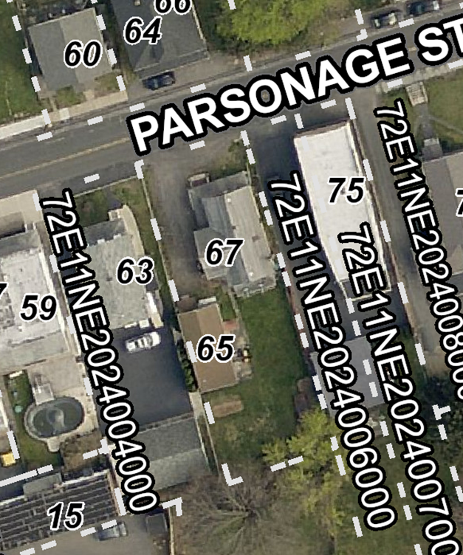

The parcel size is approximately 7,250 square feet of vacant land where a former home was demolished. The property is located in the R-2 Medium Density Residential Zoning District. For more information on Zoning or Building Codes please contact Harry Smith 570-654-0513.

1. **PROPERTY VALUE**

The Redevelopment Authority acquired the property via eminent domain for $40,000 (just compensation) based on the fair market value appraisal performed. The property is currently assessed at $124,900. The Authority “quieted” the title and there are no outstanding taxes, fees or liens.

1. **PROPERTY ACCESS**

Interested parties may access the property by drive by at any time.

1. **DEVELOPER’S DESIRED QUALIFICATIONS**
2. Previous experience in successfully redeveloping land and homes
3. Financial capacity to undertake the project
4. Ideals and goals that match the Land Bank’s mission
5. Unique take, vision or ideas
6. **TIMELINE**

May 28 – Release of RFP

July 15 (Noon) – Responses Due

July 16 to August 2 – Review Period

August 3 – Interviews, if necessary

August 3 or September 7 – Notification of Decision

1. **SUBMISSION REQUIREMENTS**
2. 2 hard copies
3. Project approach and narrative describing the project
4. List and summary description of relevant work (within the last 5 years) including project costs and methods, amounts and sources of financing.
5. Conceptual plans or narrative format for plans
6. Project ownership structure.
7. Project budget.
8. Project schedule.
9. **RESPONSE TERMS**
10. All proposals and materials submitted become the property of the North East Pa Land Bank, and as such, concepts contained therein are not protected/the proposer may assert no protection thereof. Materials will not be returned to proposers.
11. The North East Pa Land Bank has the right to use any and all ideas, or adaptations of any or all ideas, contained in all responses received, subject to the proprietary limitations stated herein. Disqualification, selection, or rejection of a response(s) does not restrict or eliminate this right of use of any or all ideas.
12. All submittals in response to this invitation become public record and become subject to public inspection. Do not ask that the entire proposal be deemed confidential; in accordance with applicable law it cannot be. The Redevelopment Authority of the City of Pittston will decide all questions of confidentiality and proprietary information.
13. The respondent agrees that the North East Pa Land Bank shall not be liable for any action or inaction of a respondent that constitutes claimed or actual patent, trademark or copyright infringement or any other claim, demand, cause of action or liability for an asserted or actual taking of or interference with an intellectual property right howsoever the claim may be stated.
14. No North East Pa Land Bank official, or employee, may have any personal, business or financial interest in any proposal.
15. This request does not commit the North East Pa Land Bank to contract for any supply or service whatsoever.
16. Respondents are advised that the North East Pa Land Bank will not pay for any information or administrative costs incurred in response to this RFP; all costs associated with responding to this RFP will be solely at the interested party’s expense.
17. **PROGRAM OR PROJECT INQUIRIES**

All questions on this program or project must be submitted in writing. No telephone inquiries will be accepted (except to schedule access). All questions and answers may be supplied to all other interested and potential respondents if deemed practical or necessary to ensure fairness. All written inquiries shall be submitted to:

North East Pa Land Bank

c/o Shannon Bonacci

35 Broad Street, Suite 202

Pittston, PA 18640

Or

[sbonacci@pittstonrda.com](mailto:cwengen@pittstonrda.com)

1. **PROPOSAL SUBMISSION**

Two (2) hard copy, sealed responses are due no later than 12:00pm (Noon), Friday, July 15, 2024 at the office of the North East Pa Land Bank, ATTENTION Parsonage Street Proposal, City Hall, 35 Broad Street, Suite 202, Pittston, PA 18640.

1. **PROPOSAL EVALUATION**

When submitting for this project, the developer’s/buyer’s reputation, history and ability to complete similar projects, as well as the buyer’s funding for the purchase and reconstruction or maintenance of the property, along with the plans the buyer has for the property. Purchase price for the property is a factor, but the North East Pa Land Bank is very interested in people who will be promoting homeownership. In addition, the North East Pa Land Bank examines the ability of the prospective developer/buyer to complete the rehabilitation. The maintenance of property he/she may already own in the City or surrounding area and the adequacy of the proposed rehabilitation work to remove blight. The North East Pa Land Bank also verifies that the prospective developer/buyer has sufficient funds to pay for the work needed on the property.

Proposals will be evaluated by the Redevelopment Authority. In no particular order or weighted measure, selection criteria shall include but not be limited to:

1. Team knowledge/skills and abilities
2. Project development and implementation methodology
3. Economic Impact to the surrounding neighborhood
4. Purchase price
5. Project ability to increase tax base for City of Pittston
6. Previous relevant experience
7. Proof of financial capacity
8. **AWARDING BID/SALE TO DEVELOPER**

The process is carried on during competitive public negotiations-not a sealed bid to highest bidder. Both private individuals and nonprofit agencies compete for available properties. The members of the North East Pa Land Bank staff may interview prospective buyers privately in an information gathering session. If there are multiple offers for one of the properties or if the purchase price is less than the just compensation price, a discussion will be held in an effort to come to a decision about which proposal best meets the goal of removing blight. The North East Pa Land Bank often makes its decision based on the best proposal that promotes homeownership or returns properties to the tax base.

If a decision is reached, motions are made and seconded to convey the property to the

prospective buyer. The buyer has the right to choose a title company and final settlement date not longer than 60 days from the meeting date. At the time of final settlement, the buyer will receive a free and clear title to the property. A Special Warranty Deed and a Quitclaim Deed are signed at the final settlement and the deeds are recorded. At the end of the rehabilitation period on or before 12 months from the date of purchase of the property, the property is inspected and a staff member of the Redevelopment Authority approves a Certification of Completion. If the property has been rehabilitated according to the plan presented, the Quitclaim Deed is returned to the property owner. The property may then be resold to a qualified homeowner. A deed restriction shall be placed on the property requiring owner-occupancy in perpetuity.

**EXHIBITS**

**EXHIBIT A – WRIT OF POSSESSION**

**EXHIBIT B – ACTION OF QUIET TITLE**

**EXHIBIT A**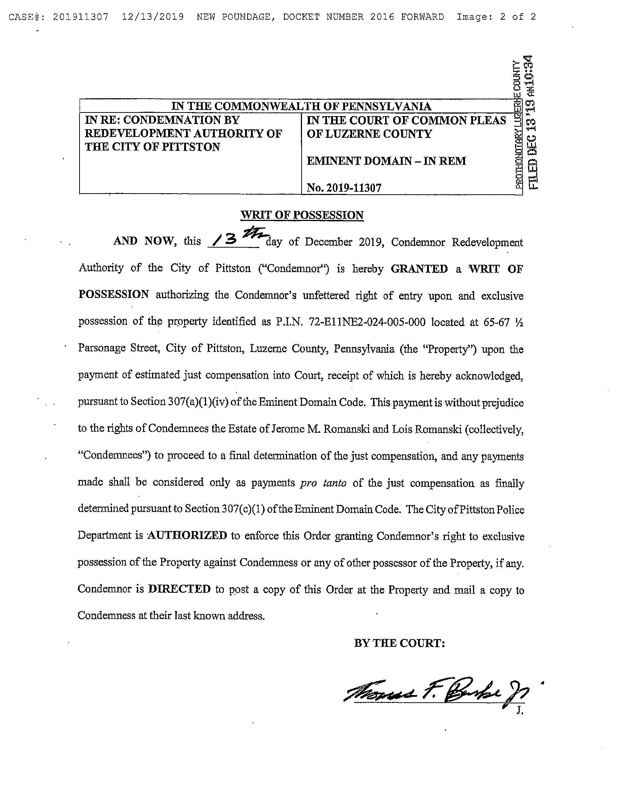

**EXHIBIT B**